**Distributed setup:**

Distributed set up we will use same machine as master and as slave

Ip address of current laptop: command prompt-ipconfig

Gives ipv4 config copy the config.

go Apache JMeter folder/bin-open the JMeter properties file-make changed to remote_hosts section

Add remote _host=Our computer Ip address.

In the same file search for server.rmi.ssl.disable-Remove the #

Set server.rmi.ssl.disable = true

Again go to appache folder/bin folder and search for a file with name: create-rmi-keystore -> windows batch file,This file is executable. Double click on it and it will open a command prompt and enter details and press enter.

A file with name rmi_keystore.jks will get generated, In the bin folder itself search for jmeter-server -> windows batch file doble click and opens command prompt and make connection.

Now open JMeter and add thread and for thread add java request and listener as given below.

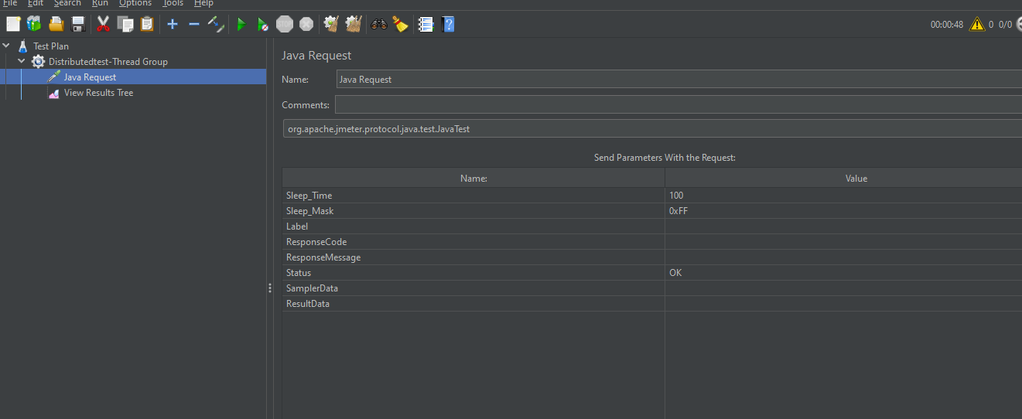

Now click Run at top run -Click on remote start

